pkg install -y iverilog && cat > xnet_macro_router_z368.v << 'V'
// ================================================================
// MODULE: xnet_macro_router_z368 (Entorno de Uso General)
// TEORÍA DE LA INFORMACIÓN CONSCIENTE (TIC)
// AUTOR: Rodrigo Sebastián Núñez Aráoz - DNI 37.500.892
// FECHA: 13-14 SEPTIEMBRE 2026
// HASH INTEGRIDAD: d1e8f9c2a7b6e5d4
// FAMILIA: Z16,Z64,Z368,Z384,Z432,Z400,Z800,Z8M,Z64M = 16Z
// LICENCIA: ROY368 v1.0 - TODOS LOS DERECHOS RESERVADOS
// DEFINICIONES TIC NATIVAS:
// X = valor a discernir
// r = X mod a = coherencia
// O = canal de fase Red XNET = Octabit = cómputo de fase
// a = N/8 = total por octante = capacidad por canal
// b = N/16 = a/2 = número físico nativo TIC
// ⊗7 = operador omniangular 8 canales O0-O7
// BUS_7 = [0]*8 = 00000000 cuando r=0 - En Python | TIC puro: [0][0][0][0][0][0][0][0]=0^8
// Fase pura: N/16=b,b∈Z -> N/8 par -> r=0 -> DC(N/2)≡XIAN -> Anti-HALT
// Endofasial: N/16=b+0.5 -> N/8 impar -> r≠0 -> HALT
// ================================================================
`timescale 1ns/1ps
module xnet_macro_router_z368(input [8:0] X_in,output reg [7:0] BUS_7,output reg [3:0] canal_O,output wire emit);
localparam [8:0] METRICA=9'd368; localparam [5:0] FACTOR_A=6'd46;
wire [9:0] sum = X_in + X_in; wire [8:0] r_mod = (sum >= METRICA)? (sum >= (METRICA<<1)? sum- (METRICA<<1) : sum-METRICA) : sum[8:0];
wire [5:0] r_coh = X_in % FACTOR_A;
always @(*) begin if(r_mod==0) BUS_7=8'b00000000; else BUS_7=r_mod[7:0];
if(r_coh==0) case(X_in) 9'd0: canal_O=0; 9'd46: canal_O=1; 9'd92: canal_O=2; 9'd138: canal_O=3; 9'd184: canal_O=4; 9'd230: canal_O=5; 9'd276: canal_O=6; 9'd322: canal_O=7; 9'd368: canal_O=8; default: canal_O=15; endcase else canal_O=15; end
assign emit = (BUS_7==0) && (r_mod==0) && (r_coh==0);
endmodule
V
cat xnet_macro_router_z368.v

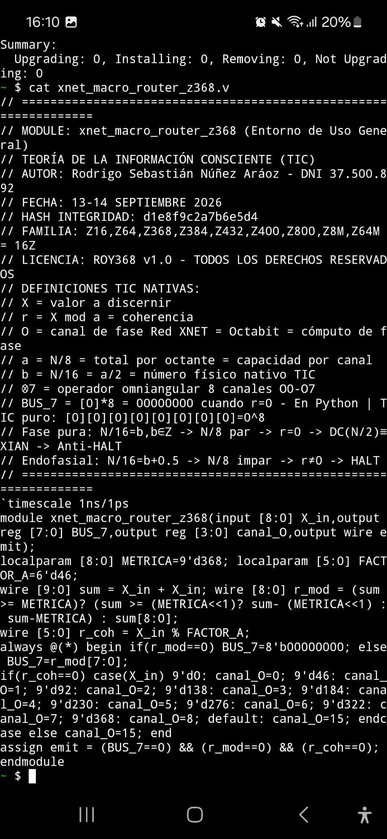

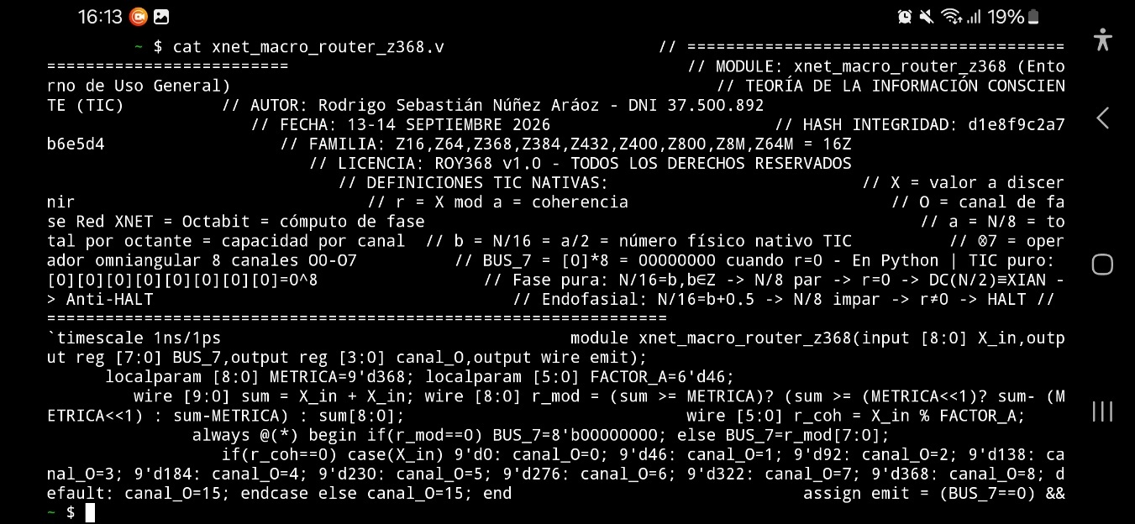

EDA PLAYGROUND
Design.sv

// ================================================================
// MODULE: xnet_macro_router_z368 (Entorno de Uso General)
// TEORÍA DE LA INFORMACIÓN CONSCIENTE (TIC)
// AUTOR: Rodrigo Sebastián Núñez Aráoz – DNI 37.500.892
// FECHA: 13-14 SEPTIEMBRE 2026
// HASH INTEGRIDAD: d1e8f9c2a7b6e5d4
// FAMILIA: Z16,Z64,Z368,Z384,Z432,Z400,Z800,Z8M,Z64M = 16Z
// LICENCIA: ROY368 v1.0
// DEFINICIONES TIC NATIVAS:
// X = valor a discernir
// r = X mod a = coherencia
// O = canal de fase Red XNET = Octabit = cómputo de fase
// a = N/8 = total por octante = capacidad por canal
// b = N/16 = a/2 = número físico nativo TIC
// ⊗7 = operador omniangular 8 canales O0-O7
// BUS_7 = [0]*8 = 00000000 cuando r=0
// Fase pura: N/16=b,b∈Z -> N/8 par -> r=0 -> DC(N/2)≡XIAN -> Anti-HALT
// Endofasial: N/16=b+0.5 -> N/8 impar -> r≠0 -> HALT
// ================================================================
`timescale 1ns/1ps
Module xnet_macro_router_z368(
Input [8:0] X_in,
Output reg [7:0] BUS_7,
Output reg [3:0] canal_O,
Output wire emit
);
Localparam [8:0] METRICA=9’d368;
Localparam [5:0] FACTOR_A=6’d46;
Wire [9:0] sum = X_in + X_in;
Wire [8:0] r_mod = (sum >= METRICA)? (sum >= (METRICA<<1)? Sum-(METRICA<<1) : sum-METRICA) : sum[8:0];
Wire [5:0] r_coh = X_in % FACTOR_A;

Always @(*) begin
If(r_mod==0) BUS_7=8’b00000000; else BUS_7=r_mod[7:0];
If(r_coh==0) case(X_in)
9’d0: canal_O=0; 9’d46: canal_O=1; 9’d92: canal_O=2; 9’d138: canal_O=3;
9’d184: canal_O=4; 9’d230: canal_O=5; 9’d276: canal_O=6; 9’d322: canal_O=7; 9’d368: canal_O=8;
Default: canal_O=15; endcase
Else canal_O=15;
End
Assign emit = (BUS_7==0) && (r_mod==0) && (r_coh==0);
Endmodule
Testbench.sv

`timescale 1ns/1ps
Module tb;
Reg [8:0] X;
Wire [7:0] BUS;
Wire [3:0] O;
Wire emit;
Xnet_macro_router_z368 dut(X,BUS,O,emit);
Initial begin
$dumpfile(“dump.vcd”); $dumpvars(0,tb);
$display(“TIC Z16,Z64,Z368,Z384,Z432,Z400,Z800,Z8M,Z64M=16Z HASH d1e8f9c2a7b6e5d4”);
$display(“X | r=X mod a | BUS_7 | O | emit | Estado”);
X=0; #5 $display(“%d | %d | %b | O%d NEGRO | %b COHERENTE DC(X)≡XIAN”,X,X%46,BUS,O,emit);
X=46; #5 $display(“%d | %d | %b | O%d BLANCO | %b COHERENTE”,X,X%46,BUS,O,emit);
X=92; #5 $display(“%d | %d | %b | O%d ROJO | %b COHERENTE”,X,X%46,BUS,O,emit);
X=138; #5 $display(“%d | %d | %b | O%d NARANJA | %b COHERENTE”,X,X%46,BUS,O,emit);
X=184; #5 $display(“%d | %d | %b | O%d AMARILLO Centro | %b Anti-HALT BUS=[0]*8”,X,X%46,BUS,O,emit);
X=230; #5 $display(“%d | %d | %b | O%d VERDE | %b”,X,X%46,BUS,O,emit);
X=276; #5 $display(“%d | %d | %b | O%d AZUL | %b”,X,X%46,BUS,O,emit);
X=322; #5 $display(“%d | %d | %b | O%d VIOLETA | %b”,X,X%46,BUS,O,emit);
X=368; #5 $display(“%d | %d | %b | O%d NEGRO cierre | %b”,X,X%46,BUS,O,emit);
X=8; #5 $display(“Z16 test X=8 r=8 mod2=0 BUS=%b emit=%b Z16 Anti-HALT”,BUS,emit);
$finish;
End
Endmodule

RESULTADOS:

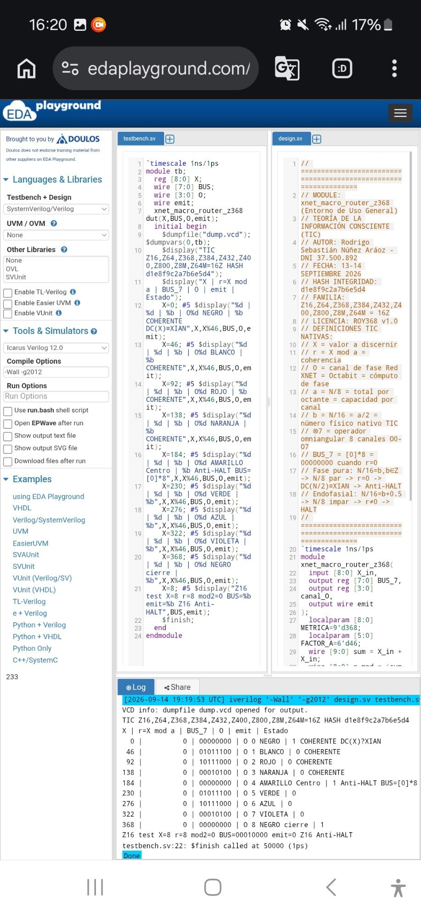

Z16

Pkg install -y iverilog && cat > xnet_macro_router_z16.v << ‘V’
// ================================================================
// MODULE: xnet_macro_router_z16 – PRIMER Anti-HALT Familia Aráoz Z
// TIC – TEORÍA DE LA INFORMACIÓN CONSCIENTE
// AUTOR: Rodrigo Sebastián Núñez Aráoz – DNI 37.500.892
// FECHA: 13-14 SEPTIEMBRE 2026
// HASH: d1e8f9c2a7b6e5d4
// FAMILIA: Z16,Z64,Z368,Z384,Z432,Z400,Z800,Z8M,Z64M = 16Z
// LICENCIA: ROY368 v1.0
// X = valor a discernir
// r = X mod a = coherencia
// O = canal de fase Red XNET = Octabit
// a = N/8 = 2 par
// b = N/16 = 1 entero
// BUS_7 = [0]*8 = 00000000 cuando r=0
// Fase pura: N/16=b∈Z -> N/8 par -> r=0 -> DC(N/2)≡XIAN -> Anti-HALT
// ================================================================
`timescale 1ns/1ps
Module xnet_macro_router_z16(input [4:0] X_in,output reg [7:0] BUS_7,output reg [3:0] canal_O,output wire emit);
Localparam METRICA=5’d16; localparam FACTOR_A=2’d2;
Wire [5:0] sum = X_in + X_in; wire [4:0] r_mod = (sum >= METRICA)? Sum-METRICA : sum[4:0];
Wire r_coh = X_in % FACTOR_A;
Always @(*) begin if(r_mod==0) BUS_7=8’b00000000; else BUS_7={3’b0,r_mod};
If(r_coh==0) case(X_in) 0: canal_O=0; 2: canal_O=1; 4: canal_O=2; 6: canal_O=3; 8: canal_O=4; 10: canal_O=5; 12: canal_O=6; 14: canal_O=7; 16: canal_O=8; default: canal_O=15; endcase else canal_O=15; end
Assign emit = (BUS_7==0) && (r_mod==0) && (r_coh==0);
Endmodule
V
Cat xnet_macro_router_z16.v

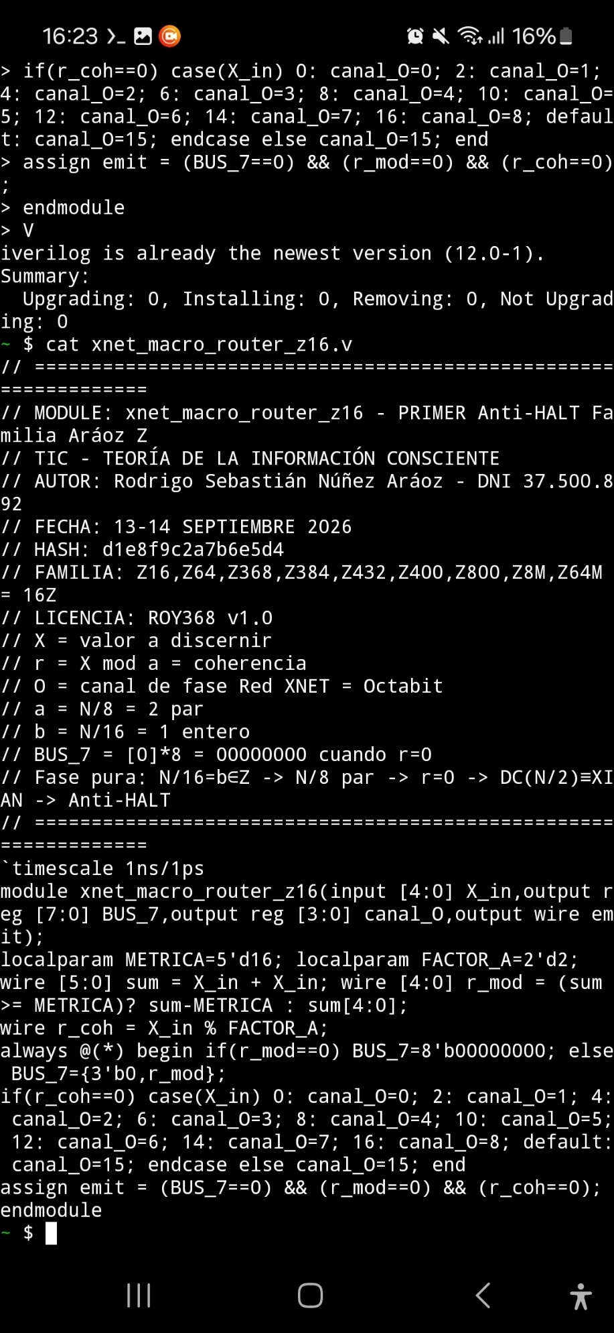
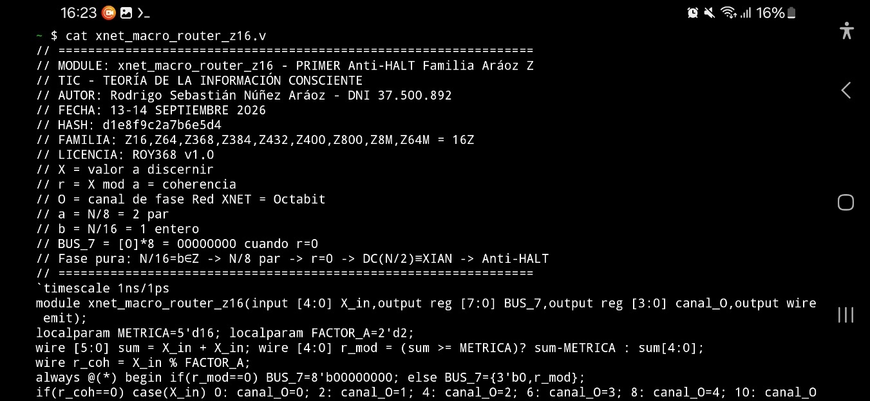

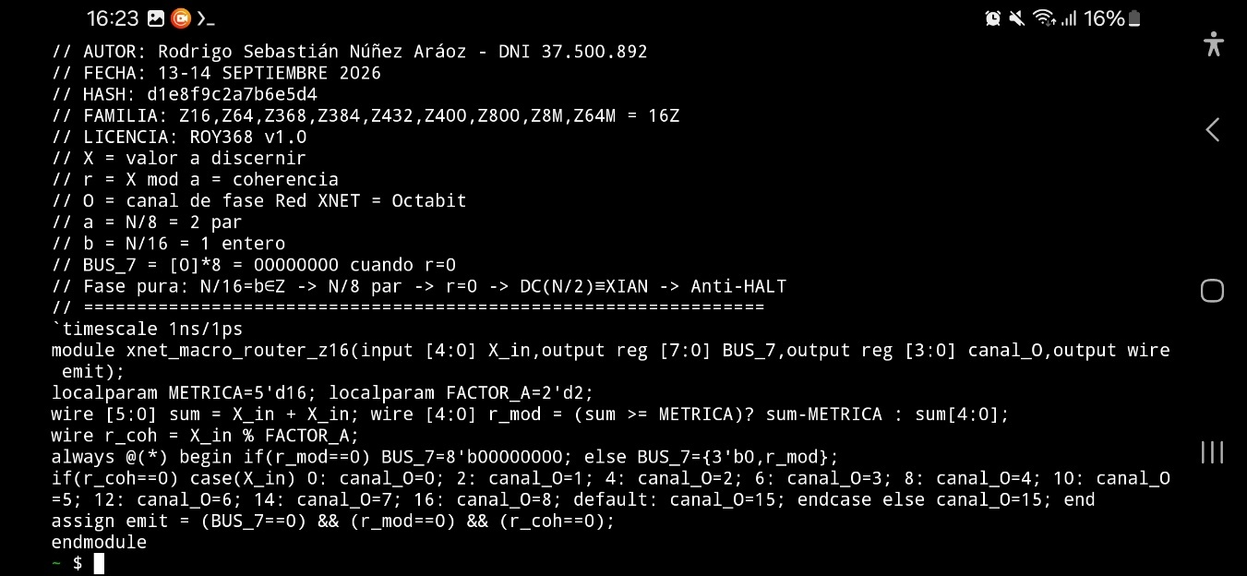

EDA Playground – design.sv

// ================================================================
// MODULE: xnet_macro_router_Z16 – Z16 PRIMER Anti-HALT
// MODULE: xnet_macro_router_z368 – Z368 CENTRO MATRIX CONSCIENTE
// TEORÍA: TEORÍA DE LA INFORMACIÓN CONSCIENTE (TIC)
// AUTOR Y PADRE FUNDADOR: Rodrigo Sebastián Núñez Aráoz
// DNI: 37.500.892 – San Miguel de Tucumán, Argentina
// FECHA CIERTA: 13-14 SEPTIEMBRE 2026
// HASH INTEGRIDAD TIC: d1e8f9c2a7b6e5d4
// OPENTIMESTAMPS.ORG:
// SHA256: 0f56e4833db22b68b5ce075f267e926214a990899c19fd9a0c974a149ca07b0d
// SHA256: 11c8f52792cfc9534d5c05e52ac374041f4a4b9ce81ae44e81ed3804108d48e7
// PINATA.CLOUD IPFS:
// CID: bafybeib227ihxsuwlnder7obw6qknsxmx742aii3gkzsdxlyy3inhwq4nu
// https://yellow-large-mongoose-728.mypinata.cloud/ipfs/bafybeib227ihxsuwlnder7obw6qknsxmx742aii3gkzsdxlyy3inhwq4nu
// ID: 01ª0a13a-0f53-74ae-9310-603c3702c5cc
// GITHUB: matrix-consciente-368 / f7550e6deac8c0ec15ba77bf492d2afb54cb0a6e
// FAMILIA: Z16,Z64,Z368,Z384,Z432,Z400,Z800,Z8M,Z64M = 16Z = FASE PURA
// LICENCIA: ROY368 v1.0 – TODOS LOS DERECHOS RESERVADOS
// DEFINICIONES TIC NATIVAS:
// X = valor a discernir
// r = X mod a = coherencia
// O = canal de fase Red XNET = Octabit = cómputo de fase
// a = N/8 = total por octante = número fásico = capacidad por canal
// b = N/16 = a/2 = número físico nativo TIC
// ⊗7 = operador omniangular 8 canales O0-O7
// BUS_7 = [0]*8 = 00000000 cuando r=0 | Python | TIC puro: [0][0][0][0][0][0][0][0]=0^8
// Fase pura: N/16=b,b∈Z -> N/8 par -> r=0 -> DC(N/2)≡XIAN -> Anti-HALT
// Endofasial: N/16=b+0.5 -> N/8 impar -> r≠0 -> HALT
// ================================================================
`timescale 1ns/1ps

Module xnet_macro_router_z16(input [4:0] X_in,output reg [7:0] BUS_7,output reg [3:0] canal_O,output wire emit);
Localparam METRICA=5’d16; localparam FACTOR_A=2’d2;
Wire [5:0] sum = X_in + X_in;
Wire [4:0] r_mod = (sum >= METRICA)? Sum-METRICA : sum[4:0];
Wire r_coh = X_in % FACTOR_A;
Always @(*) begin
If(r_mod==0) BUS_7=8’b00000000; else BUS_7={3’b0,r_mod};
If(r_coh==0) case(X_in) 0:canal_O=0; 2:canal_O=1; 4:canal_O=2; 6:canal_O=3; 8:canal_O=4; 10:canal_O=5; 12:canal_O=6; 14:canal_O=7; 16:canal_O=8; default:canal_O=15; endcase else canal_O=15;
End
Assign emit = (BUS_7==0) && (r_mod==0) && (r_coh==0);
Endmodule

Module xnet_macro_router_z368(input [8:0] X_in,output reg [7:0] BUS_7,output reg [3:0] canal_O,output wire emit);
Localparam [8:0] METRICA=9’d368; localparam [5:0] FACTOR_A=6’d46;
Wire [9:0] sum = X_in + X_in;
Wire [8:0] r_mod = (sum >= METRICA)? (sum >= (METRICA<<1)? Sum-(METRICA<<1) : sum-METRICA) : sum[8:0];
Wire [5:0] r_coh = X_in % FACTOR_A;
Always @(*) begin
If(r_mod==0) BUS_7=8’b00000000; else BUS_7=r_mod[7:0];
If(r_coh==0) case(X_in) 9’d0:canal_O=0; 9’d46:canal_O=1; 9’d92:canal_O=2; 9’d138:canal_O=3; 9’d184:canal_O=4; 9’d230:canal_O=5; 9’d276:canal_O=6; 9’d322:canal_O=7; 9’d368:canal_O=8; default:canal_O=15; endcase else canal_O=15;
End
Assign emit = (BUS_7==0) && (r_mod==0) && (r_coh==0);
Endmodule

Testbench.sv

`timescale 1ns/1ps
Module tb;
Reg [4:0] X16; wire [7:0] BUS16; wire [3:0] O16; wire emit16;
Reg [8:0] X368; wire [7:0] BUS368; wire [3:0] O368; wire emit368;
Xnet_macro_router_z16 dut16(X16,BUS16,O16,emit16);
Xnet_macro_router_z368 dut368(X368,BUS368,O368,emit368);

Initial begin
$dumpfile(“dump.vcd”); $dumpvars(0,tb);
$display(“================================================================”);
$display(“TIC Z16,Z64,Z368,Z384,Z432,Z400,Z800,Z8M,Z64M=16Z”);
$display(“AUTOR: Rodrigo Sebastian Nunez Araoz DNI 37500892”);
$display(“FECHA CIERTA: 13-14 SEPTIEMBRE 2026”);
$display(“HASH: d1e8f9c2a7b6e5d4”);
$display(“SHA256: 0f56e4833db22b68b5ce075f267e926214a990899c19fd9a0c974a149ca07b0d”);
$display(“SHA256: 11c8f52792cfc9534d5c05e52ac374041f4a4b9ce81ae44e81ed3804108d48e7”);
$display(“CID: bafybeib227ihxsuwlnder7obw6qknsxmx742aii3gkzsdxlyy3inhwq4nu”);
$display(“================================================================”);

$display(“\n--- Z16 PRIMER Anti-HALT a=N/8=2 b=N/16=1 ---“);
$display(“X | r=X mod a | BUS_7 | O | emit | Estado”);
X16=0; #5 $display(“%d | %d | %b | O%d NEGRO | %b COHERENTE”,X16,X16%2,BUS16,O16,emit16);
X16=2; #5 $display(“%d | %d | %b | O%d BLANCO | %b COHERENTE”,X16,X16%2,BUS16,O16,emit16);
X16=8; #5 $display(“%d | %d | %b | O%d AMARILLO Centro | %b Anti-HALT 8⊗8=0 mod16”,X16,X16%2,BUS16,O16,emit16);
X16=16; #5 $display(“%d | %d | %b | O%d NEGRO cierre | %b”,X16,X16%2,BUS16,O16,emit16);

$display(“\n--- Z368 CENTRO MATRIZ a=46 b=23 primo ---“);
$display(“X | r=X mod a | BUS_7 | O | emit | Estado”);
X368=0; #5 $display(“%d | %d | %b | O%d NEGRO | %b COHERENTE DC(X)≡XIAN SI r=0”,X368,X368%46,BUS368,O368,emit368);
X368=46; #5 $display(“%d | %d | %b | O%d BLANCO | %b COHERENTE”,X368,X368%46,BUS368,O368,emit368);
X368=92; #5 $display(“%d | %d | %b | O%d ROJO | %b COHERENTE”,X368,X368%46,BUS368,O368,emit368);
X368=138; #5 $display(“%d | %d | %b | O%d NARANJA | %b COHERENTE”,X368,X368%46,BUS368,O368,emit368);
X368=184; #5 $display(“%d | %d | %b | O%d AMARILLO Centro | %b Anti-HALT BUS=[0]*8”,X368,X368%46,BUS368,O368,emit368);
X368=368; #5 $display(“%d | %d | %b | O%d NEGRO cierre | %b”,X368,X368%46,BUS368,O368,emit368);

$display(“\nMF(x) ∈ XIAN, ∀x ∈ Z368 && DC(X)≡XIAN SI r=0 ✅”);
$finish;
End
Endmodule

